PROJECT FINANCE

- Create a new folder
- Right click and open gitbash
- git clone https://github.com/StarAgileDevOpsTraining/star-agile-banking-finance
4) cd star-agile-banking-finance
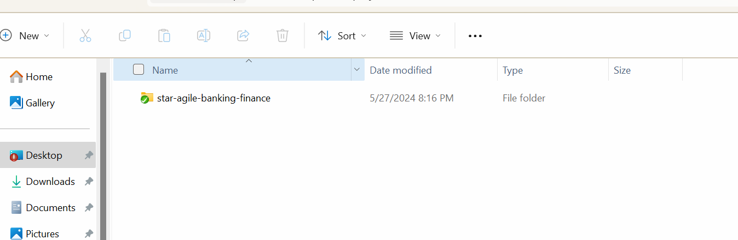

Click on the folder
- open gitbash inside the folder

Create the repo
- Now go to your github.com account and create a new repo
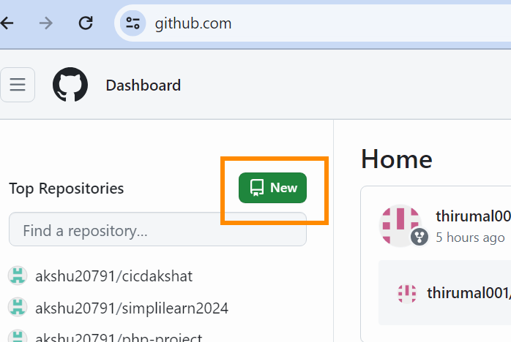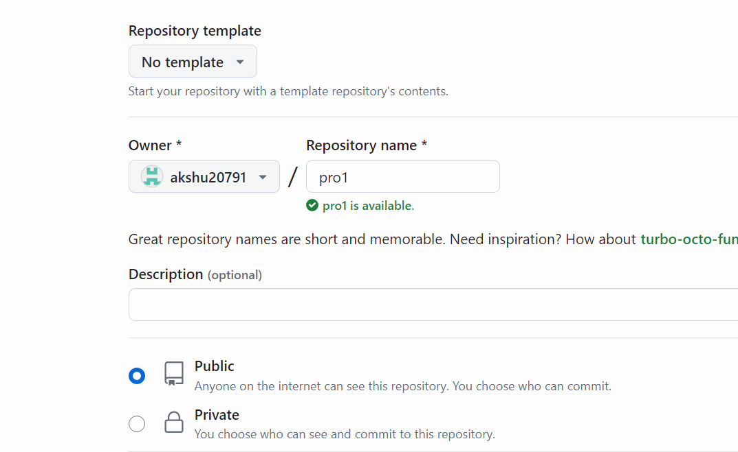

- Go to gitbash -> write
$git remote remove origin
$git remote add origin https://github.com/akshu20791/pro1
(you need to use your repo name)
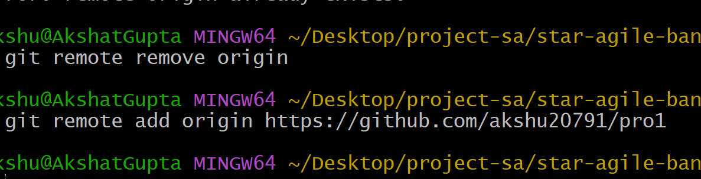

Create a PAT with repo access
https://github.com/settings/tokens/new
and generate new token with repo access
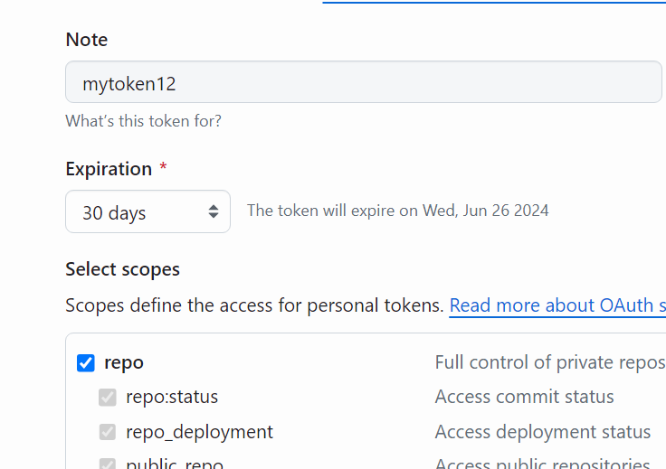

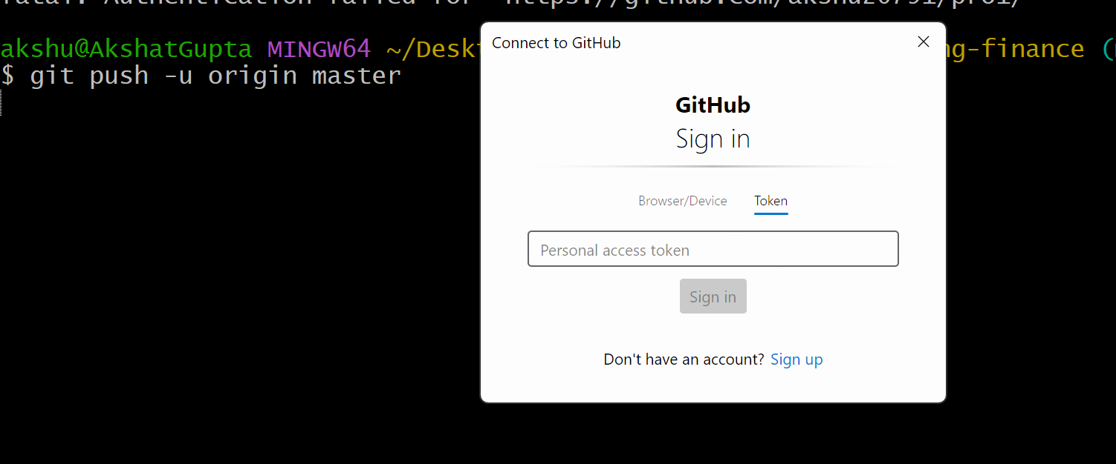

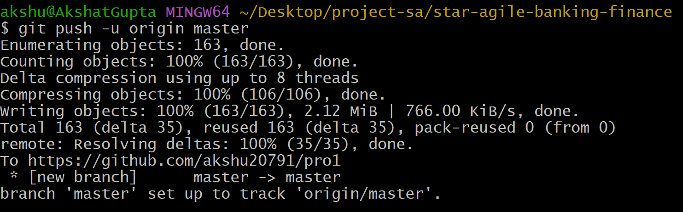

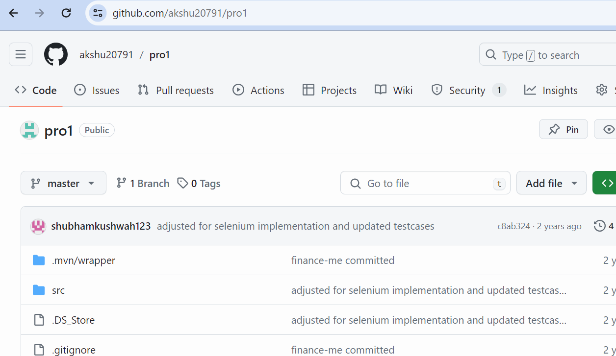

We will now create a ubuntu ec2 machine
Go to instances ->Select ec2 ->Launch instance
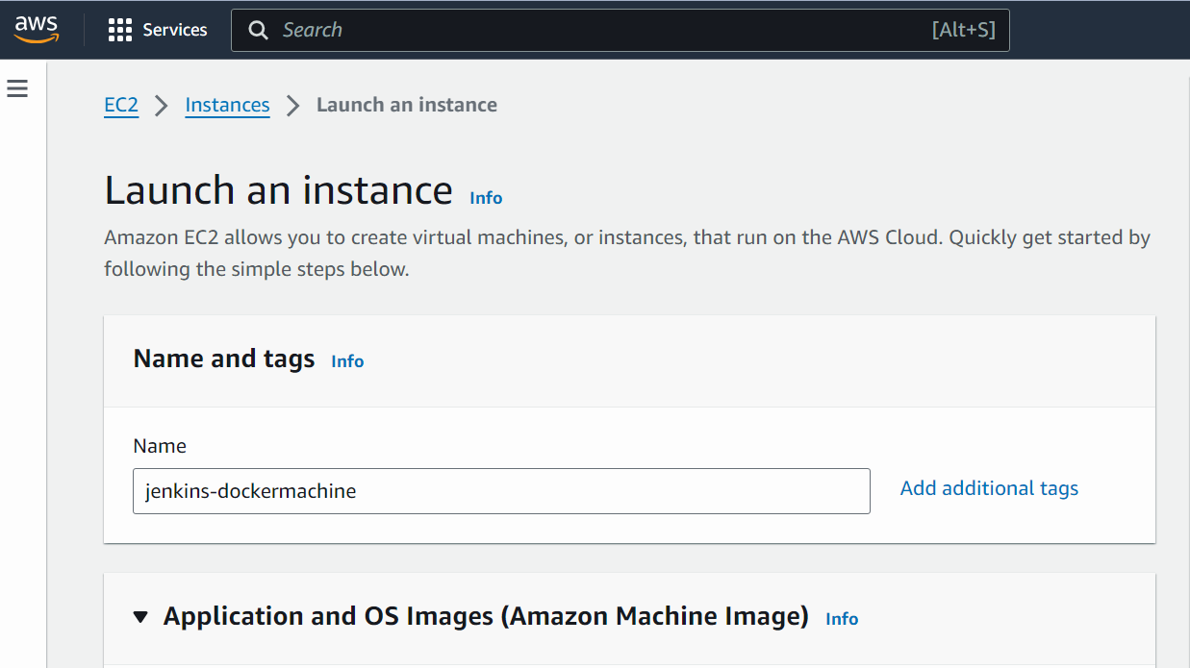

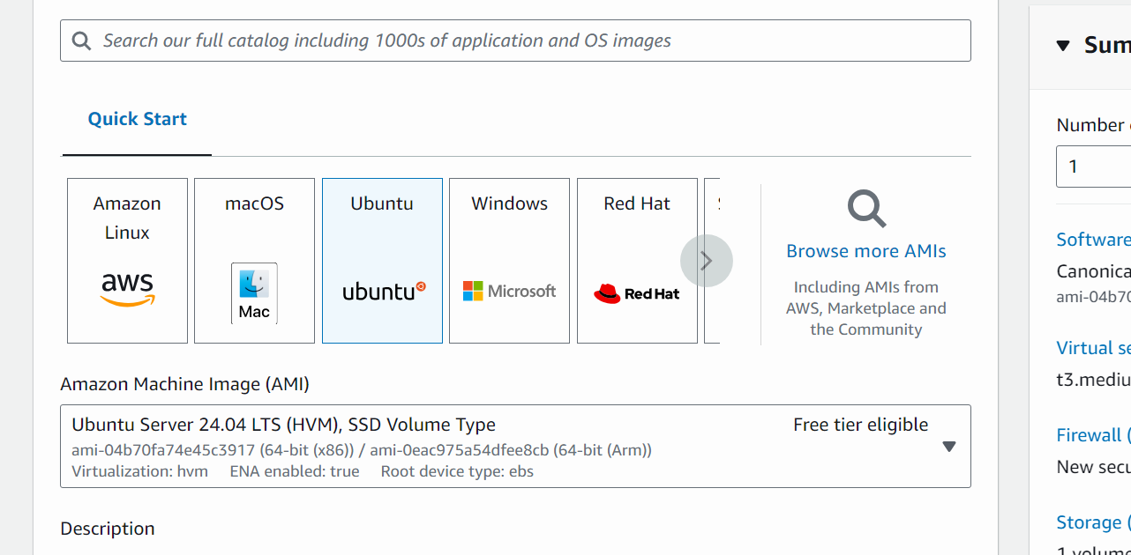

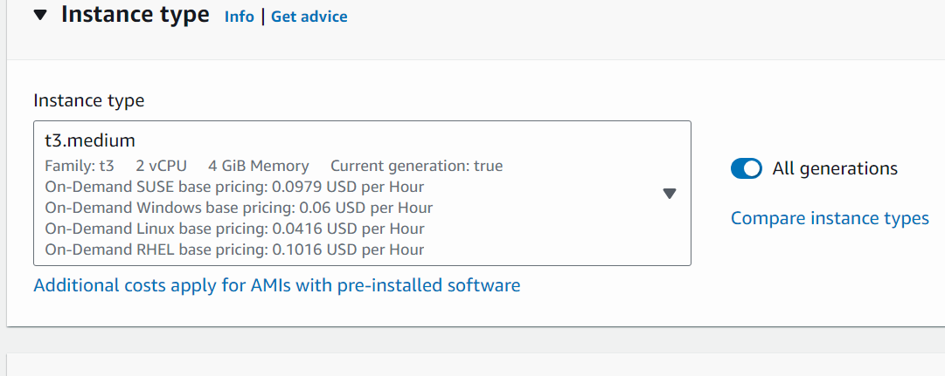
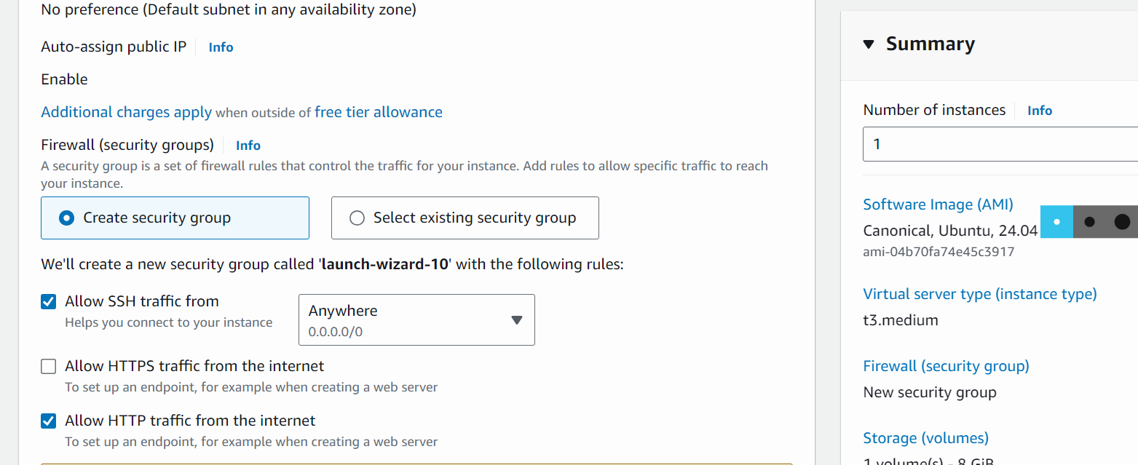

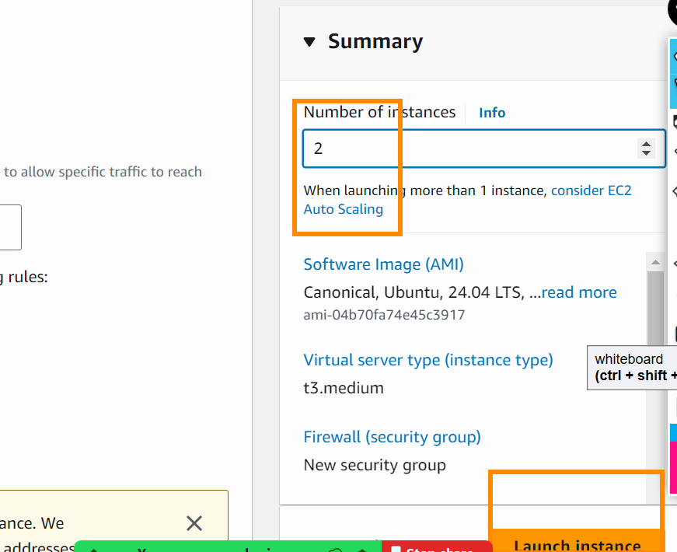

Launch instance
Rename the machine to Grafana
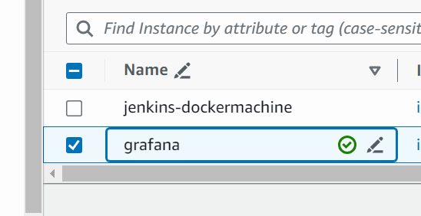

Connect to jenkinsdocker machine

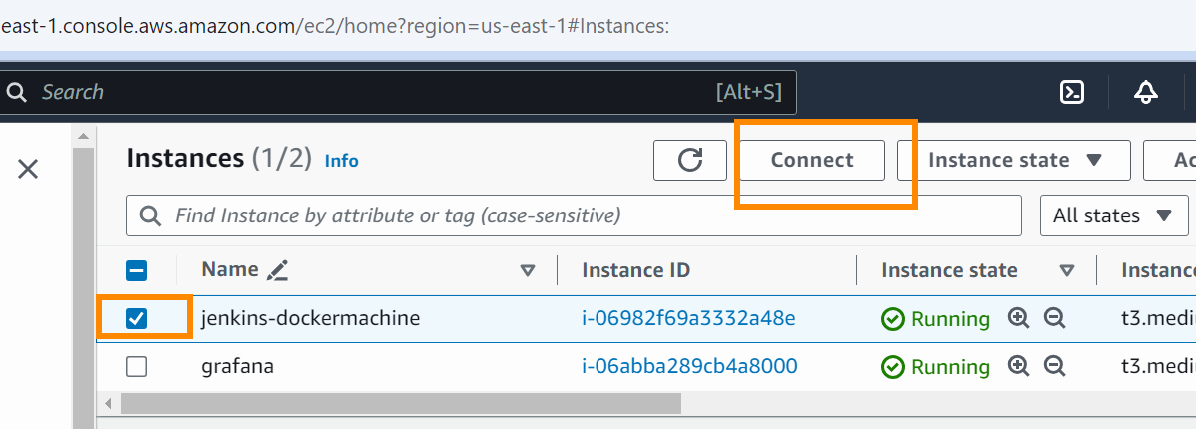

Click on launch machine

Install jenkins
- Inside the machine execute the following commands
$sudo su
$wget raw.githubusercontent.com/NikitasGithub/Deployment-script/refs/heads/main/jenkins.sh
$ls
jenkins.sh
$chmod +x jenkins.sh
jenkins.sh -> green -> execute permissions enabled
$./jenkins.sh
Copy the public ip:8080
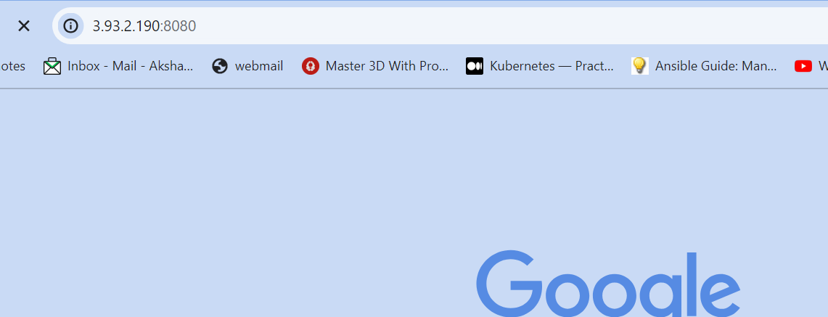
This will not open because we need to enable inbound rule
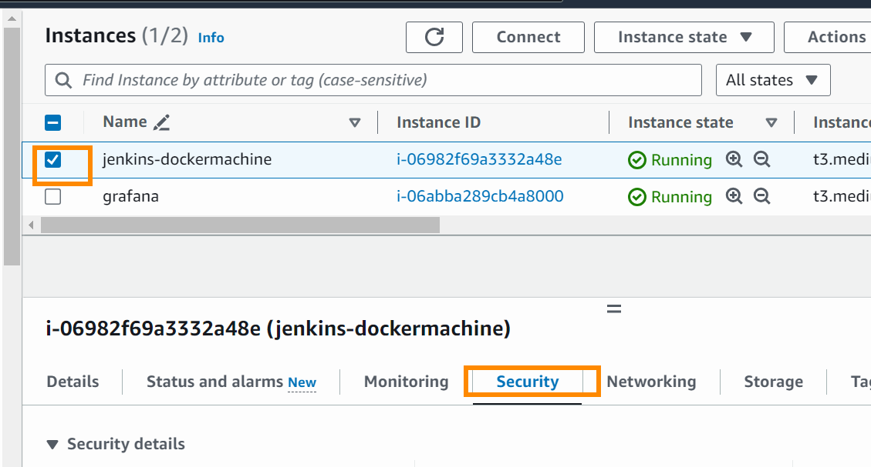

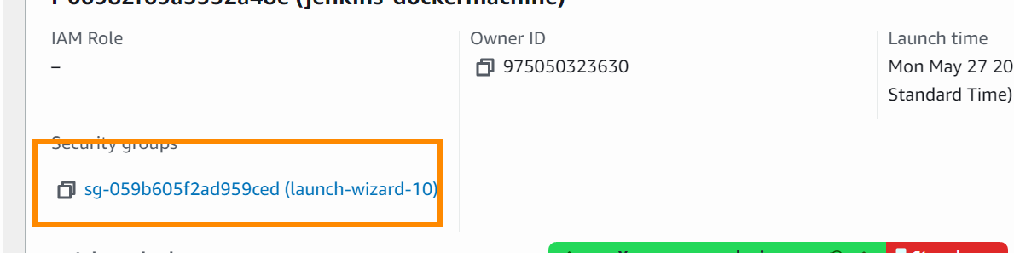
Edit inbound rile
Add all traffic
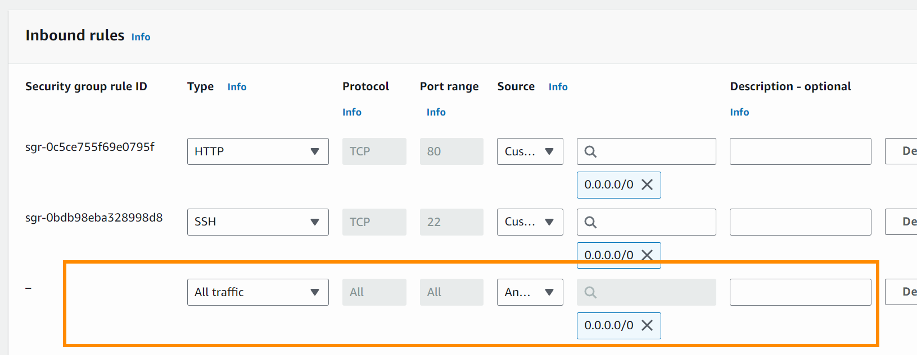

Copy the password of jenkins
$cat /var/lib/jenkins/secrets/initialAdminPassword

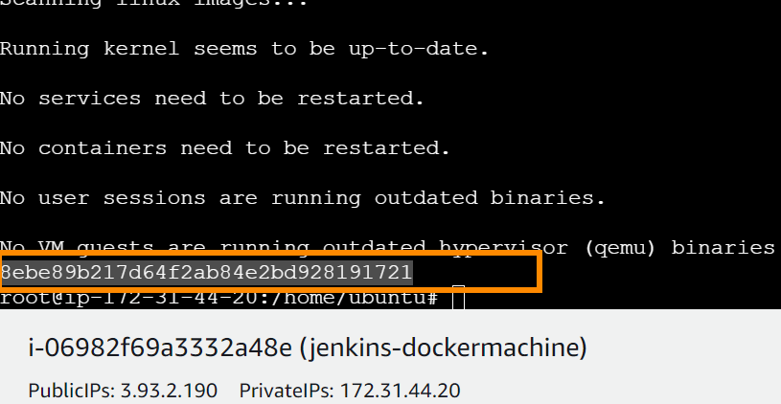
Paste it here
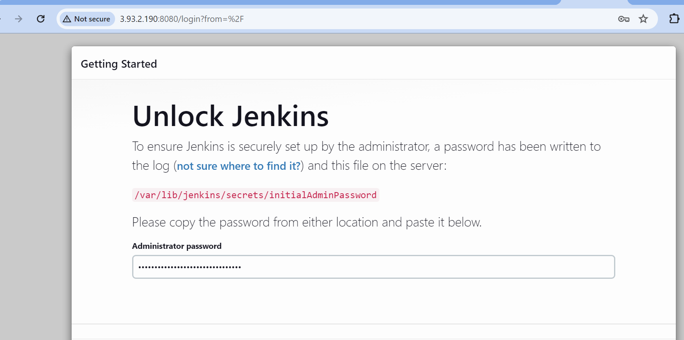

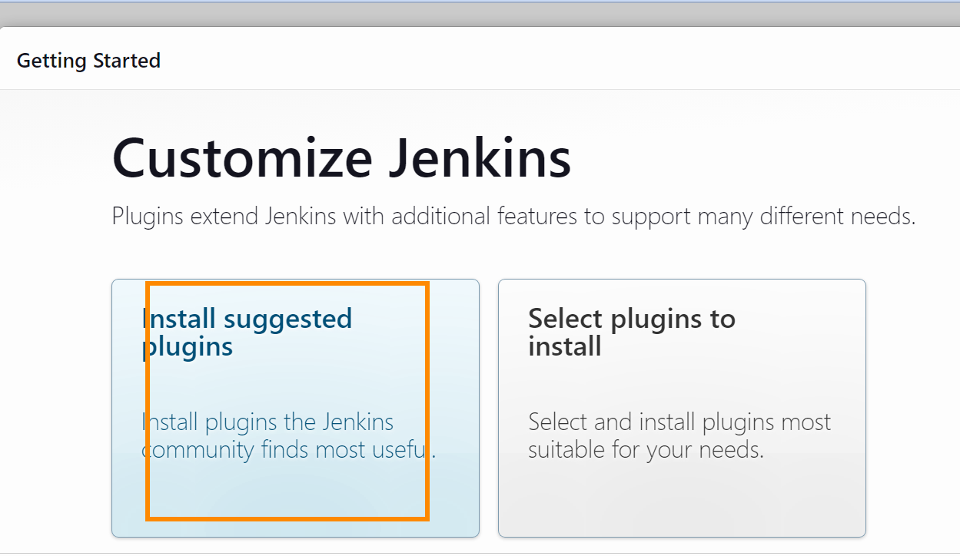
Put admin admin as username and pass
Go back to your ec2 machine

Install docker
We need to first install docker in the machine and then we will give jenkins the permission to access docker
$sudo apt install docker.io -y
$sudo usermod -aG docker jenkins
adding user jenkins to docker group
we are allowing jenkins user to run docker cmd without needing sudo
$groups jenkins
$service jenkins restart
$visudo
jenkins ALL=(ALL:ALL) NOPASSWD: ALL
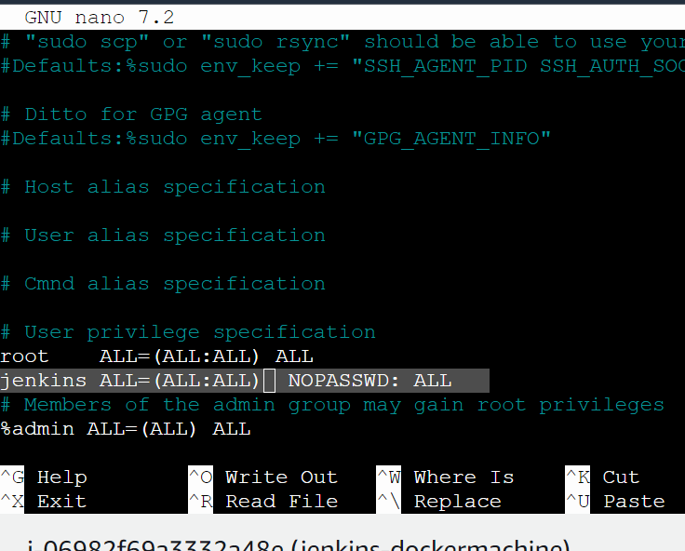

Ctrl x -> press y -> enter
$service jenkins restart
Refresh the jenkins and relogin

Install Docker plugin in jenkins
Now we will install the plugins
Go to manage credentials
Go to plugins
Available plugins

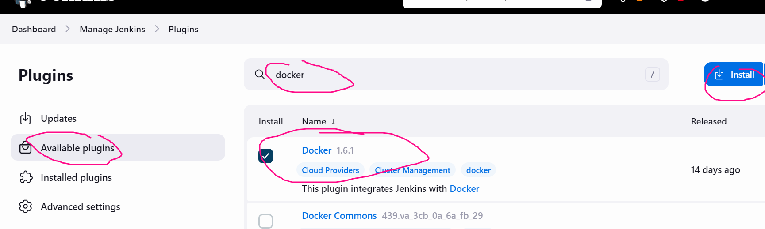

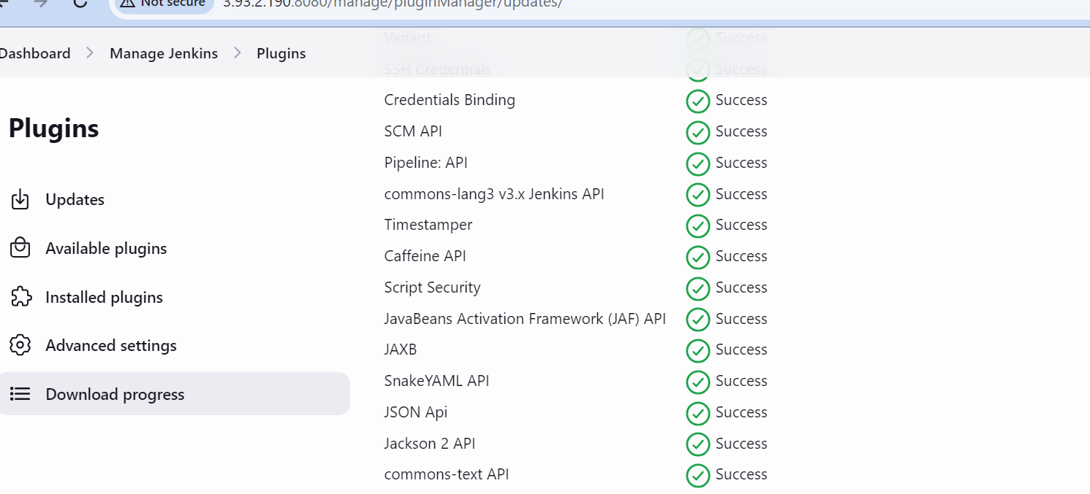

Create new item
Give the project name -> pipeline project
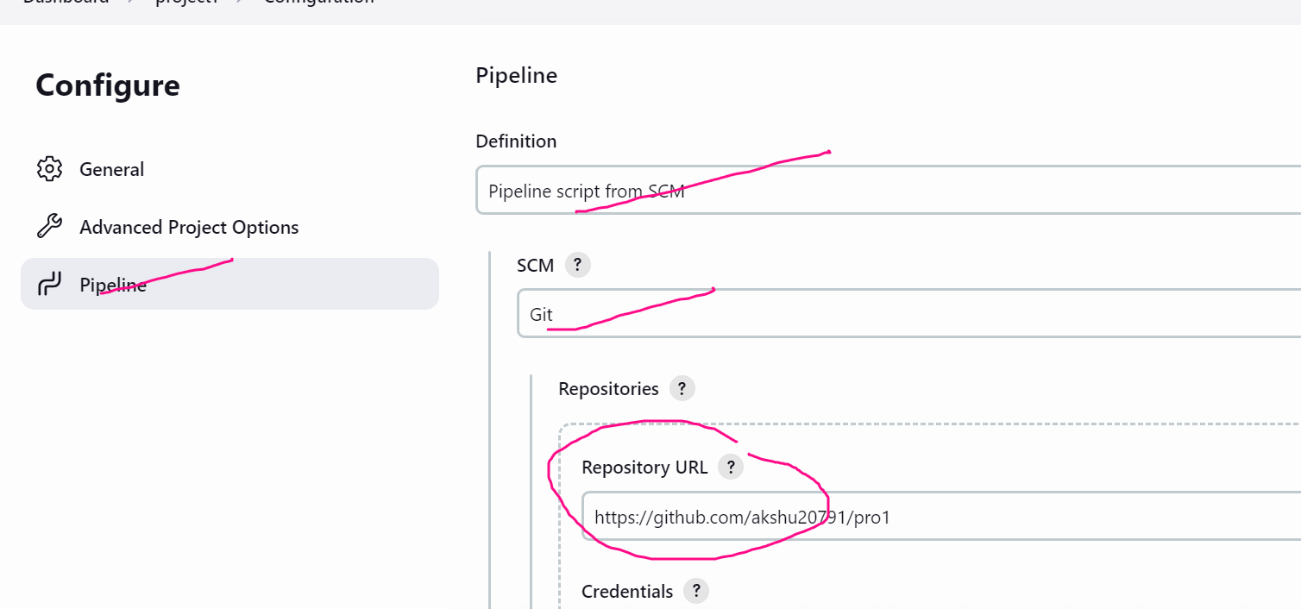

Create jenkinsfile
Step 11) We don’t have jenkinsfile so we need to write jenkinsfile
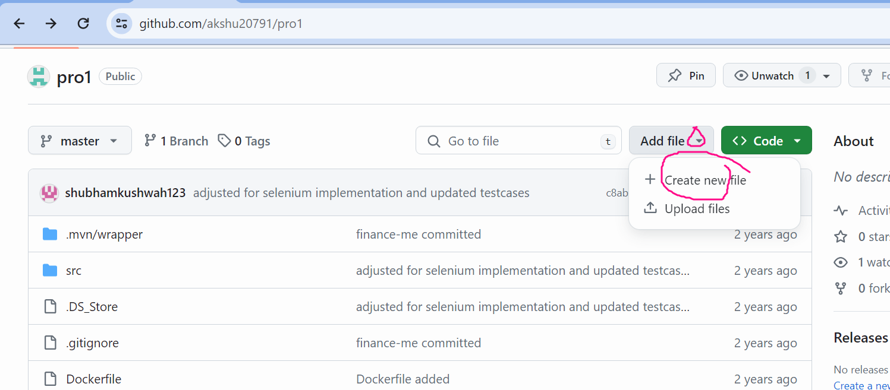

You have to create Jenkinsfile (use https://github.com/NikitasGithub/pro1/blob/master/Jenkinsfile as reference)

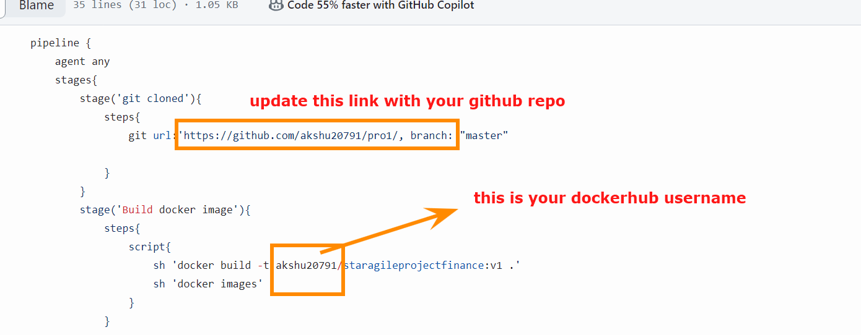

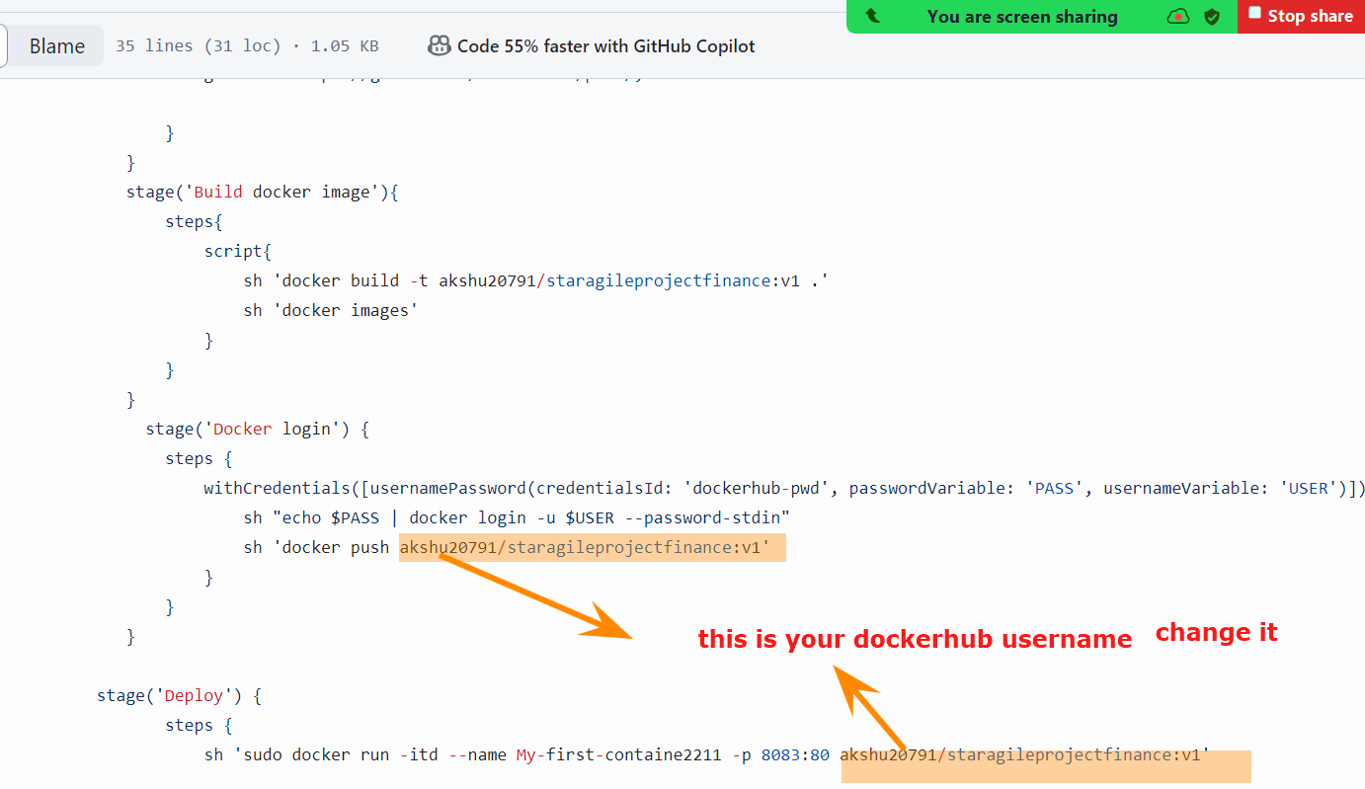

Manage Credentials
- Go to jenkins -> manage jenkins -> credentials
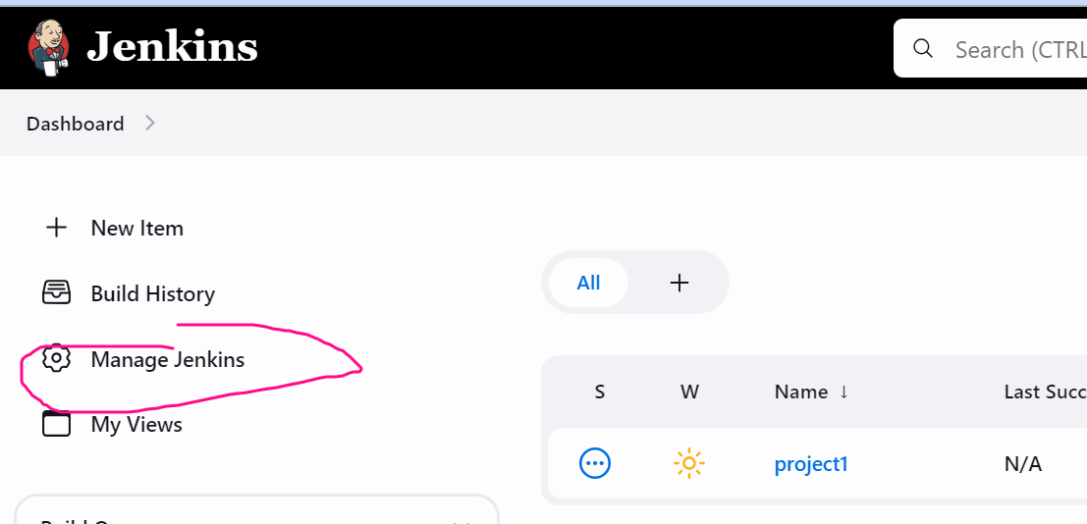

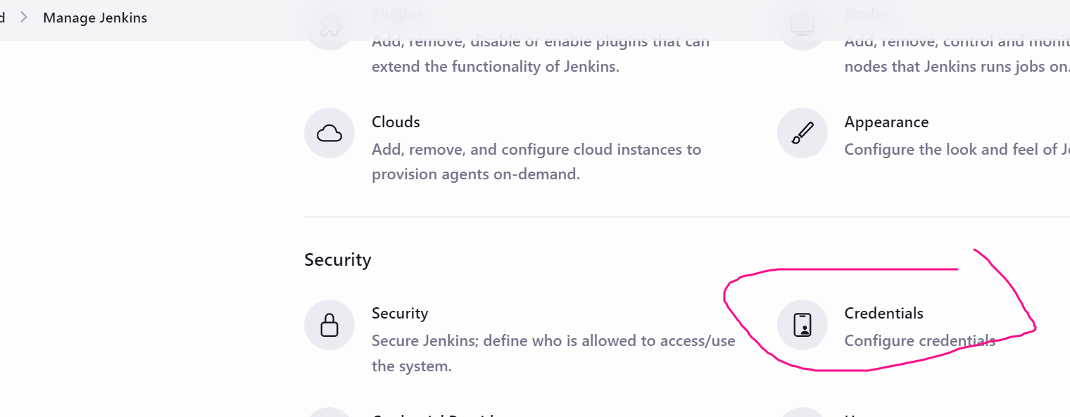

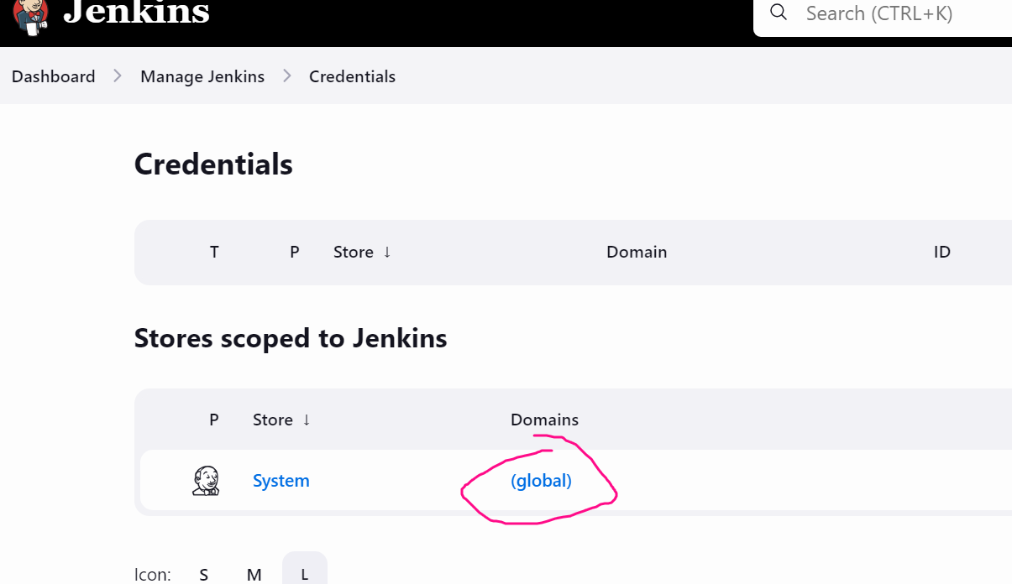

Add credentials
Kind: username with password
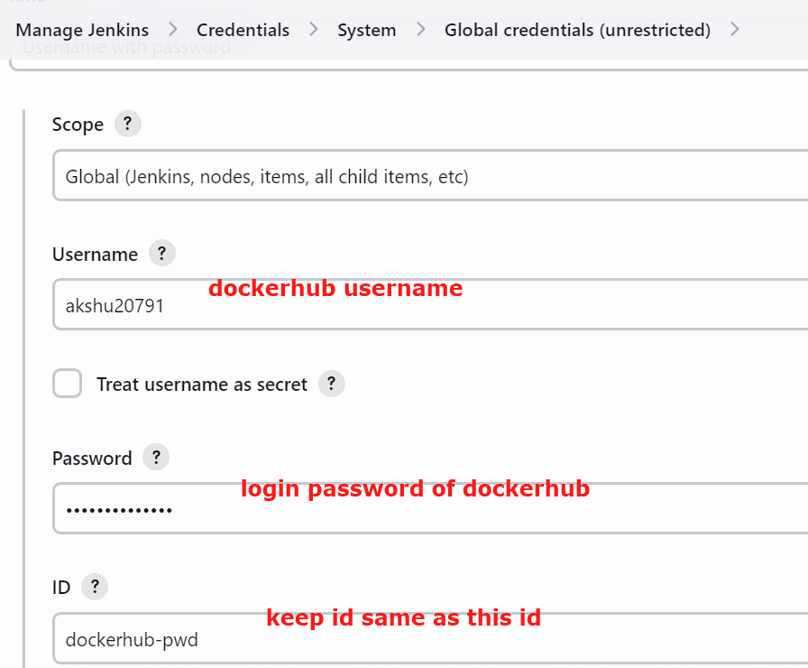

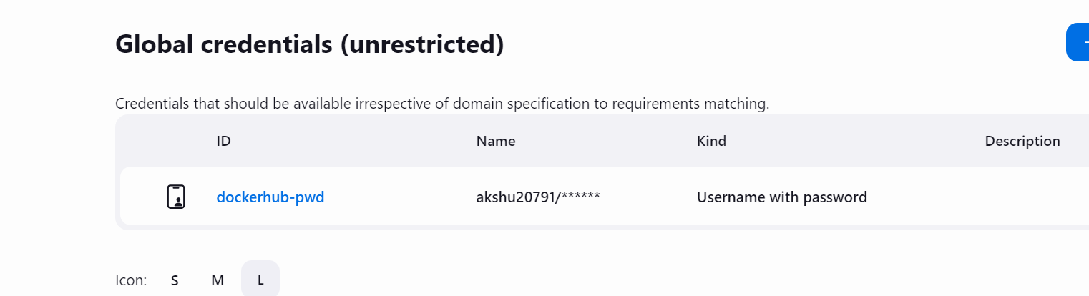

Go to the project, Build now

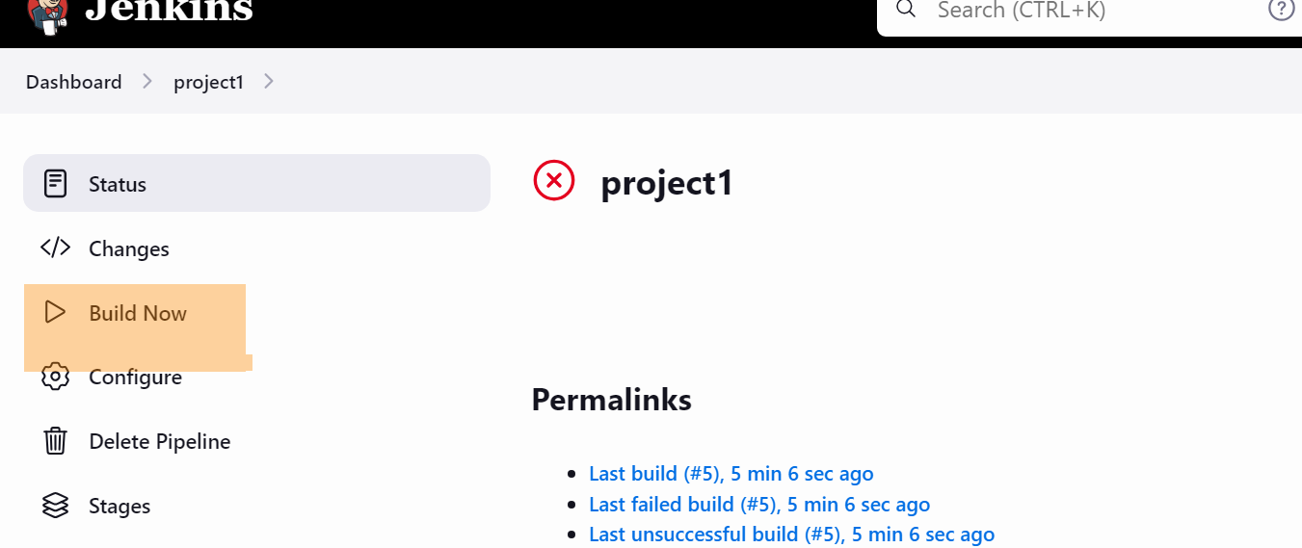

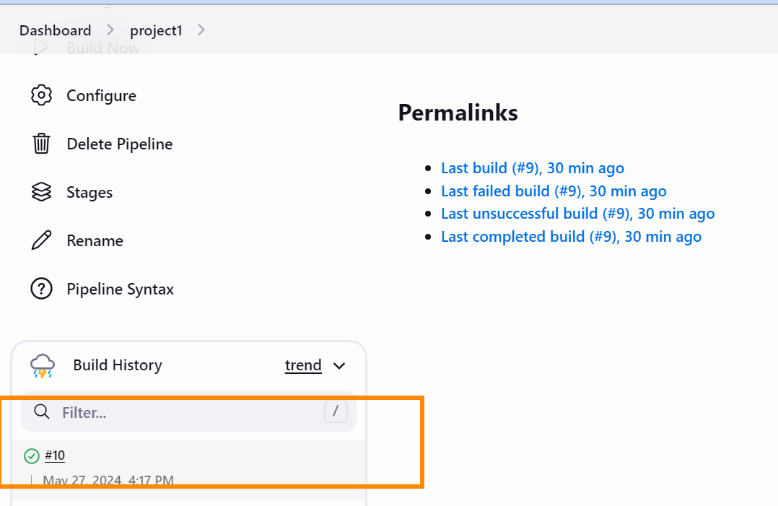

Click on latest build
